8.87: Let the proton be moving in the +-direction with speed 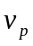 after the decay. The initial momentum of the neutron is zero, so to conserve momentum the electron must be moving in the-direction after the collision; let its speed be 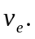
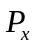 is constant gives 0 = 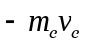 + 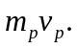
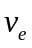 = (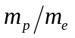) – 
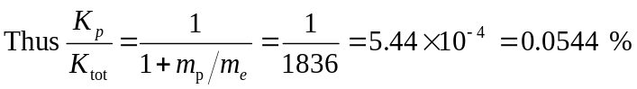 The total kinetic energy after decay is 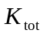 = 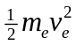+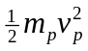. Using the momentum equation to replace 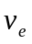 gives 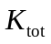 =1+ 